International Society of Air Safety Investigators, Annual Seminar, August 22-24, 2017
Using Scanning and Simulation Technology to Analyze Aviation Mishaps
By Rawson Wood, Richard Watson, and Krysta Amezcua, Biodynamic Research Corporation
Rawson Wood started work as a Consultant at the Biodynamic Research Corporation in August 2016. Prior to joining BRC, he served 27 years in the US Air Force as one of very few pilot-physicians. He has an undergraduate degree in aeronautical engineering. As a pilot he flew the C-17 as an aircraft commander, flying more than 600 hours of combat time in almost 4000 hours of military flying. As a physician he is board certified in Aerospace and Occupational medicine and commanded the Air Force’s largest hospital, leading 2500 healthcare professionals.
Richard Watson is Technical Director at Biodynamic Research Corporation (BRC) in San Antonio Texas. He has a Bachelor of Science degree in Mechanical Engineering, a Masters of Science in Biomedical Engineering, and is currently a PhD Candidate in Biomedical Engineering. Prior to collegiate training he was a Flight Engineer on CH-47D helicopters in the US Army. Mr. Watson specializes in computer simulation and performed human dynamics simulations as part of BRC’s role in the investigation of the Space Shuttle Columbia disaster.
Krysta Amezcua is a student engineer at BRC. She is finishing her Honors College Thesis as part of the undergraduate Biomedical Engineering program at the University of Texas San Antonio and expects to graduate near the top of her class. Krysta has a strong interest in the biomechanics of trauma and the applications of computer modeling. Her skill set includes the use of a supercomputing cluster to solve highly complex dynamic simulations of the human body.

Background
This paper describes a method of aircraft mishap investigation using simulation of occupant kinematics within a dimensionally accurate model of the aircraft to understand the overall dynamics of a crash and the potential for occupant injury.
To remain relevant, investigators must adopt new technology in order to better understand and demonstrate aircraft crash events. High quality investigation findings, combined with detailed analysis produces results with high confidence, which result in meaningful improvements to the aviation system. Modern scanning and modeling technology can be combined to investigate, document and understand causality. This paper will demonstrate how 3D imaging and simulation technologies can be combined to aid in the investigation of difficult biomechanical questions that frequently accompany aviation mishaps. We will demonstrate hand-held 3D scanning combined with MADYMO (Mathematical Dynamic Model) human kinematics software to provide accurate information key to understanding damage and injury in aviation mishap investigation.
Examining an intact exemplar aircraft can provide important clues to understand how the impact forces affected the occupants. Photographs may provide important information about the relationship between seats, structure and controls, however, dimensionally correct 3-D scanning provides much more useful information. Exemplar surrogates matched in size and weight as the crash occupants can be similarly scanned and placed into the aircraft model. The sizes, shapes and relationships provided by this work may be useful for predicting or matching occupant motion. If a known or assumed crash pulse is applied to this model, impact forces and resulting motions can be calculated for each represented part of the occupant’s body. The resulting simulation may shed light on injury potential, damage to the aircraft and ultimately the cause of the crash.
As causal factors in aircraft crashes are analyzed, strategies can be refined to increase primary and secondary prevention, namely how to reduce the risk of a crash occurring and secondly, of injuries to the occupants. Design curves for fixed and rotary wing aircraft, such as described by Dobbs, can be adjusted based upon ongoing research. This concept combines the vertical and forward impact velocity components to better incorporate dynamic crash survival factors. (1) Merkle studied the Human Surrogate Torso Model and the Hybrid II ATD response to a helicopter full scale crash test to relate overall and tissue-level crash responses. They expect this work to be used to validate computational human models to virtually analyze mild and severe 3-dimensional crashes without the need for full scale testing. (2)
The complexity and progress of this evolutionary process is described in an article by Annett, et al, where data from full scale crash testing with ATDs are used to explore new restraint technologies for next generation military helicopter designs. Their article highlights the complexity of aviation restraint challenges in dynamic 3-D motions for multiple occupant tasks and locations. (3)
Previous work by Annett described a method for building and validating a finite element model of a helicopter to evaluate new crash mitigation technology. While this effort does not detail time or cost required to create and test their model, it is expected to be substantial and only feasible within the research arena. They effectively predicted fuselage accelerations, but found discrepancies between test and analysis of occupant loading. (4) It is precisely this ongoing challenge of accurately describing occupant loading that drives the work we are presenting with this paper.
Methods
In March 2010, NASA crash tested a MD-500 helicopter outfitted with Anthropomorphic Test Devices and published the airframe and occupant acceleration profiles. (5) We investigated the application of 3D scanning and computer modeling software for the purpose of simulating pilot response during an MD-500 crash test. The purpose of this work was to demonstrate the results of our methodology in comparison to measurements obtained during the test. We began with an inspection of an exemplar MD-500 helicopter. Using a Mantis Pocketscan3D light-weight handheld scanner (Mantis-Vision, Petach Tikva Israel), the cockpit of the helicopter was digitized for the purpose of obtaining accurate 3D geometry as seen in Figure 1. The 3D scan data was then imported into MADYMO (TASS International, Helmond, The Netherlands), a computer modeling program used to analyze kinematic and biomechanical response of a human model to impact. Using the overlaid scan data of the cockpit, the mesh cloth bucket seat of the pilot was represented with accurate geometry. A Hybrid III 50th percentile FAA ATD was placed in the pilot seat to replicate the testing conditions of NASA’s full scale crash test. This anthropometric test device (ATD) contains a Federal Aviation Administration (FAA) approved straight lumbar spine which is capable of a more realistic response to severe vertical loading and has been applied in the development and certification of aircraft seats. The Hybrid III FAA ATD was secured in the pilot seat with a 5-point harness restrain system as seen in Figure 2. 3D scan data was used to identify the anchor points of the lap belts as well as the position of the mounted retractor for the shoulder belts. The MD-500 vertical acceleration data published in NASA’s crash test report was then digitized and applied to our MADYMO simulation.
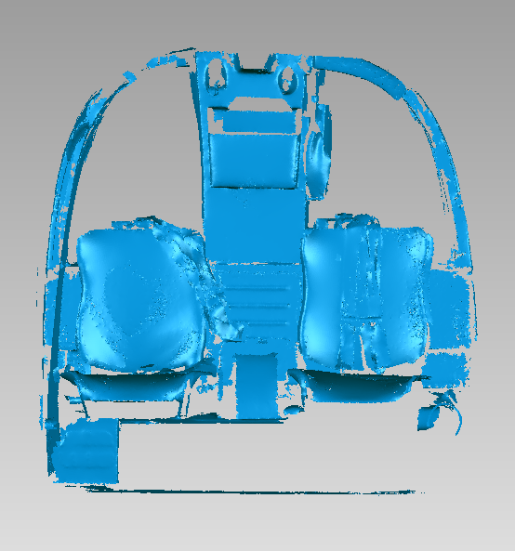
Figure 1 3D scan data of MD-500 pilot (right) and co-pilot (left) seats
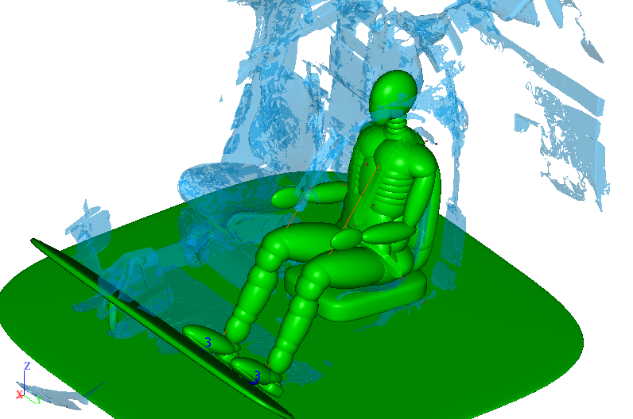
Figure 2 Hybrid III FAA ATD secured with 5-point restraint harness, MADYMO model (green) overlain on scan data (blue)

Results
The occupant response data from our MADYMO simulation of an MD-500 crash test was compared to occupant response data from NASA’s crash test. Figures 3 – 5 present pilot pelvic, chest, and head response data from our MADYMO simulation along with overlaid occupant acceleration profiles digitized from NASA’s crash test report. The peak pelvic, chest, and head resultant accelerations were 43.2 g, 43.1 g, and 38.2 g, respectively. This was compared to NASA’s peak pelvic, chest, and head accelerations reported as 42.8 g, 37.8 g, and 32.4 g, respectively.

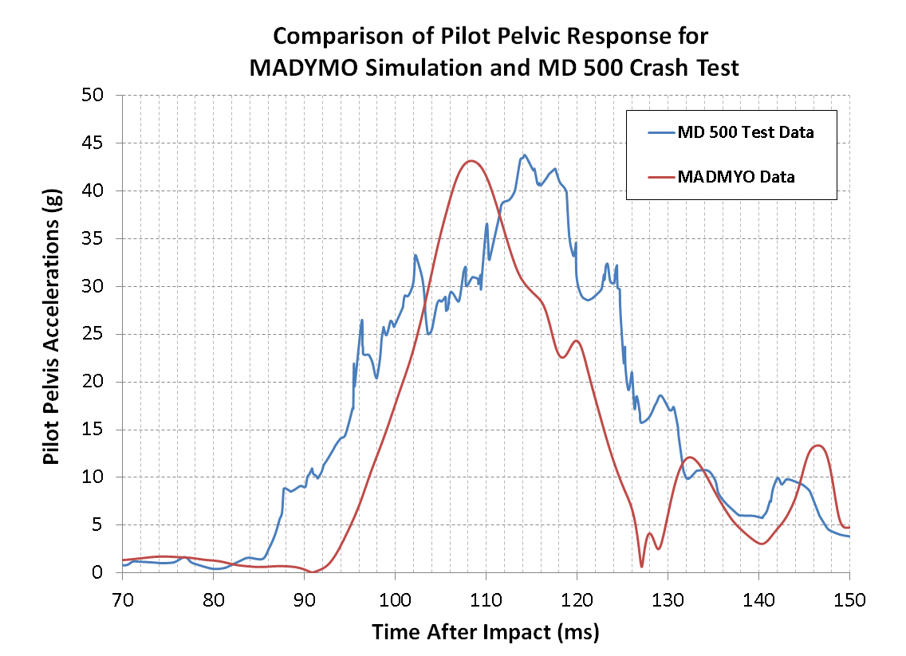
Figure 3 Comparison of pilot pelvic response

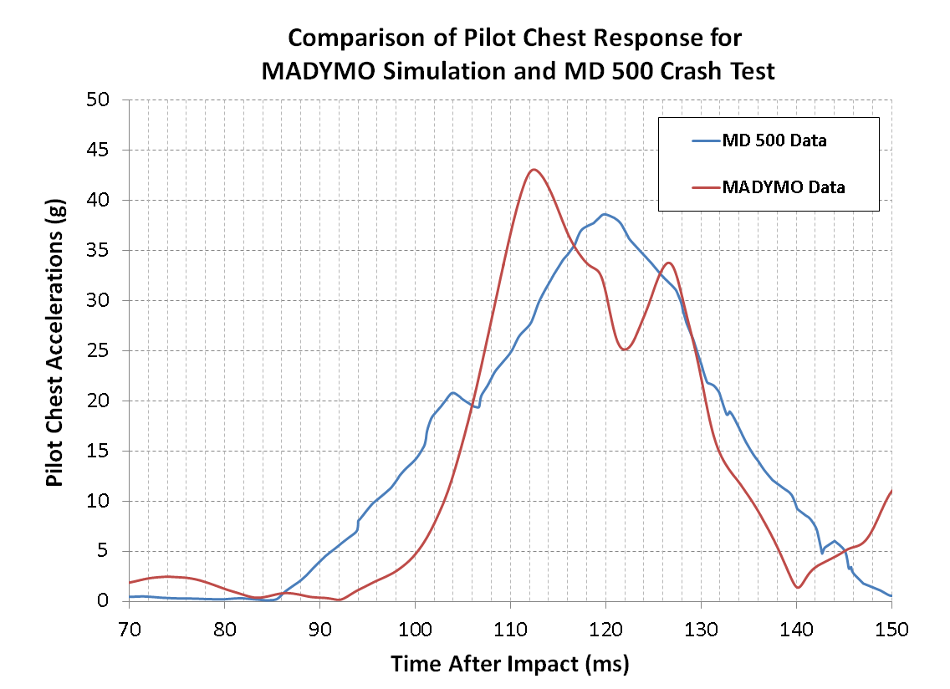
Figure 4 Comparison of pilot chest response

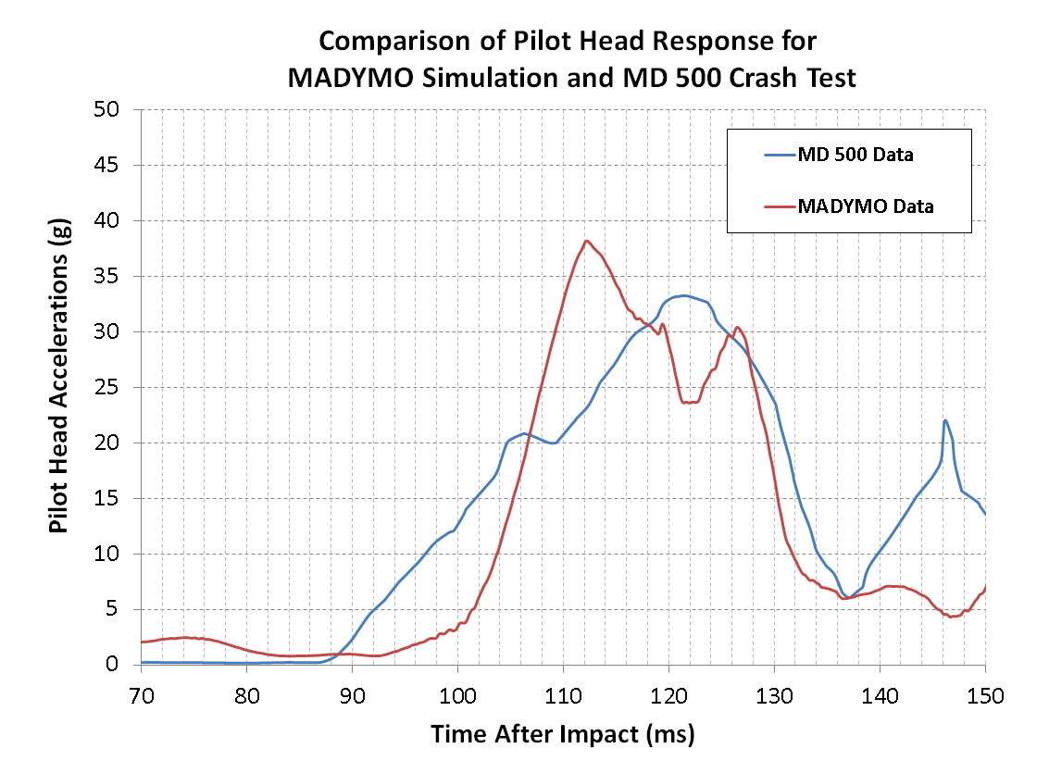
Figure 5 Comparison of pilot head response

Discussion
Our results show that a reasonably accurate model of a crashed aircraft and occupants can be created with this methodology. We were able to replicate the kinematics of the ATDs in the NASA MD 500 crash test using scanned cockpit geometry from an exemplar MD 500 and the MADYMO human dynamics software. The replication of the ATD response in the test shows the utility of this approach in the investigation of field crashes. Reconstruction of the aircraft crash sequence can be used in conjunction with the scan data and human kinematic modeling to understand the entire sequence and its effect on the occupants. This modeling can be used with evidence from inside the crashed aircraft to test the validity of the overall crash reconstruction.
Aircraft crashes often leave little undamaged structure and no witnesses or survivors to describe the sequence of events. A framework for aircraft crash injury causation analysis was documented by McMeekin. (6,7) He describes the keys to understanding injury patterns and specific injuries: the magnitude, duration and direction of acceleration forces, the cockpit/passenger compartment configuration, the nature of the accident and the occupant kinematics, particularly those relating to the restraint systems.
The replication of the ATD response in the test shows the utility of this approach in the investigation of field crashes. Reconstruction of the aircraft crash sequence can be used in conjunction with the scan data and human kinematic modeling to understand the entire sequence and its effect on the occupants. This modeling can be used with evidence from inside the crashed aircraft to test the validity of the overall crash reconstruction. The analysis-derived occupant kinematics should be close to that found in crash testing or in actual crashes.

Conclusion
This paper demonstrates a rapid, cost effective way to understand occupant injury causality in aircraft crashes. The ultimate aim of crash investigations is to understand the event itself and use this information for specific as well as general purposes. The scanning, modeling and simulation procedures we used can lead to more rapid and cost-effective understanding of crashes and subsequent design, maintenance or operations changes to improve aviation safety. Ongoing improvements to the mishap investigation process have truly made a difference by enabling aviation to become the safest form of transportation currently available.
The authors have no financial interest in any of the commercially available aircraft, devices or software presented.

References
1. Dobbs MW. Emergency landing dynamic conditions: a comparison with accident impact conditions. Int J Crashworthiness. 2013 Oct;18(5):465–72.
2. Merkle AC, Carneal CM, Wing ID, Wickwire AC, Paulson JM, Ott KA, et al. Biomechanics and injury mitigation systems program: An overview of human models for assessing injury risk in blast, ballistic, and transportation impact scenarios. Johns Hopkins APL Tech Dig. 2013;31(4):286–295.
3. Annett MS, Littell JD, Jackson KE, Bark LW, DeWeese RL, McEntire BJ. Evaluation of the First Transport Rotorcraft Airframe Crash Testbed (TRACT 1) Full-Scale Crash Test. 2014 [cited 2017 Jun 15]; Available from: https://ntrs.nasa.gov/search.jsp?R=20150001249
4. Annett MS, Polanco MA. System-integrated finite element analysis of a full-scale helicopter crash test with deployable energy absorbers. 2010 [cited 2017 Jul 5]; Available from: https://pdfs.semanticscholar.org/b54d/a8349664bb07addc6d89932b2f6cecdf10fa.pdf
5. Littell J. Full-Scale Crash Test of an MD-500 Helicopter. 2011 [cited 2017 Jun 14]; Available from: https://ntrs.nasa.gov/search.jsp?R=20110011656
6. McMeekin R. Patterns of Injury in Fatal Aircraft Accidents. In: Aerospace Pathology. Chicago, IL: College of American Pathologists Foundation; 1973. p. 86–95. (Mason, J and Reals, W, eds).
7. McMeekin R. Aircraft Accident Investigation. In: Fundamentals of Aerospace Medicine. Philadelphia; 1985. p. 762–814. (DeHart, R. Ed).

